Study of Networking Device
Q1. Identify the network address C subnet mask for the ip address 192.168.1.0

Given ip address is 192.168.1.0
The subnet mask is 255.255.255.0 as it is belong to class C

. In Binary Form:-
11111111 .11111111 .11111111.00000000
In this the 1st 24 bits represent host part.

Q2. Create 4 Subnets:-
To create 4 subnets we need to binary two bits from the host part. 2^2=4
So the new subnet mask is 255.255.255.192 Binary Form:- 11111111.11111111.11111111.11000000
so 26 bits for the network part 6 bits for host part. Total no. of subnet 4. [ combining 2 or more subnet will give us the Supernet.]
Total no. Of useable ip address in each subnet is 64- -2 because 1 address is for network and 1 for broadcast, so subtracting them. 62 IP address are useable.
CIDR format:-classless InterDomain Representaion. New Subnet Mask:- 255.255.255.192/126
The 1st subnet mask is 192.168.1.0/126 The 2nd subnet mask is 192.168.1.64/126
Subnet 1=192.168.1.0 ---> Network address Useable host address 192.168.1.62/126 Broadcast address 192.168.1.63/26

Subnet 2 192.168.1.64
1st host address 192.168.1.65

Last host address | 192.168.1.126/26
Broadcast address | 192.168.1.127
Subnet 3 | 192.168.1.128
Last address is | 192.168.1.190
15th address is | 192.168.1.129
Subnet 4 | 192.168.1.192
Last address is | 192.168.1.254
Broadcast address | 192.168.1.255

Q3. A network address 192.168.1.0/24 create 3 subnet with subnet 1 corristing if so subnet 2 with 20, and subnet 3 with 10.

(Since the no. Of host bit is determine of the ip address. So ip address formula to calculate no. Of bits required to satisfy each subnet ip address is 2^n/ no. of ip address required.
Where n is the no. of bits and +2 represent n|6) Subnet 1 of 50 ip address
Ex:- 2^6 = 64 with 62 useable ip address we need 6 host bits. Subnet mask is 255.255.255.192/26
2^5 = 32 ,30 useable
Subnet mask is 255.255.255.224|27 2^4=16
Subnet 255.255.255.140|28
Subnet 1
Subnet mask: 255.255.255.192|26

Network address 192.168.1.0|26 Host address 192.168.1.1|26
Last host address 192.168.1.50|26 Useable ip address 62//
Broadcast 192.168.1.63|26

Q. Demonstrate the Static Routing in Packet Tracer.
Aim : To write a code to demonstrate static routing in packet tracer. Steps:
- In packet tracer take 2 PCs and 2 Routers.
- Connect Router0 with PC0 via fastethernet0/0 using cross-copper cord and Router1 with PC1 via fasethernet0/0 using cross-copper cord.
- Connect both router via fastethernet0/1 using cross-copper cord.
- Set the IP address and default gateway of both the PCs in ip configuration of both the PCs respectively.

Topology:
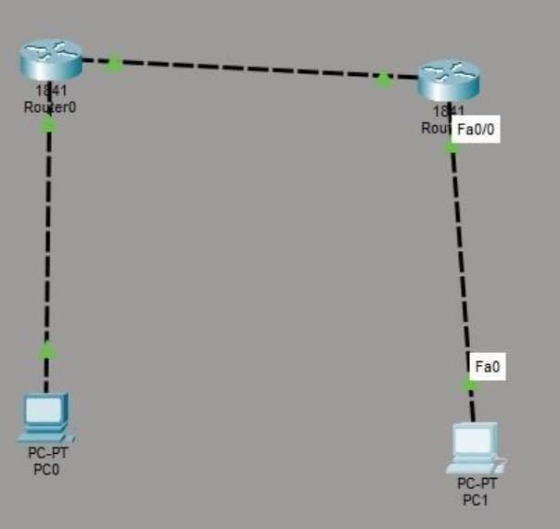
Code: Router0:
Router> enable
Router# configure terminal

Router(config)# interface fastethernet0/0 Router(config-if)# ip address 10.0.0.1 255.0.0.0 Router(config-if)# no shutdown
Router(config-if)# exit
Router(config)# interface fastethernet0/1 Router(config-if)# ip address 20.0.0.1 255.0.0.0 Router(config-if)# no shutdown
Router(config-if)# exit
Router(config)#ip route 40.0.0.0 255.0.0.0 20.0.0.2 Router(config)#exit Router1:
Router> enable
Router# configure terminal Router(config)# interface fastethernet0/0
Router(config-if)# ip address 20.0.0.2 255.0.0.0 Router(config-if)# no shutdown
Router(config-if)# exit
Router(config)# interface fastethernet0/1 Router(config-if)# ip address 40.0.0.1 255.0.0.0 Router(config-if)# no shutdown
Router(config-if)# exit
Router(config)#ip route 10.0.0.0 255.0.0.0 20.0.0.1 Router(config)#exit

PC0:
Verification: In Both PCs Command Prompt.

C:\ipconfig

C:\ping 10.0.0.1
C:\ping 10.0.0.2
C:\ping 20.0.0.1
C:\ping 20.0.0.2
C:\ping 40.0.0.1
C\:ping 40.0.0.2 PC1:
C:\ipconfig C:ping 40.0.0.1
C:ping 20.0.0.2
C:ping 20.0.0.1
C:ping 10.0.0.1
C:ping 10.0.0.2

Output:
PC0:
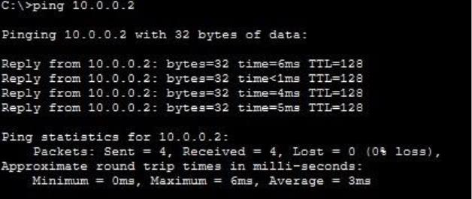

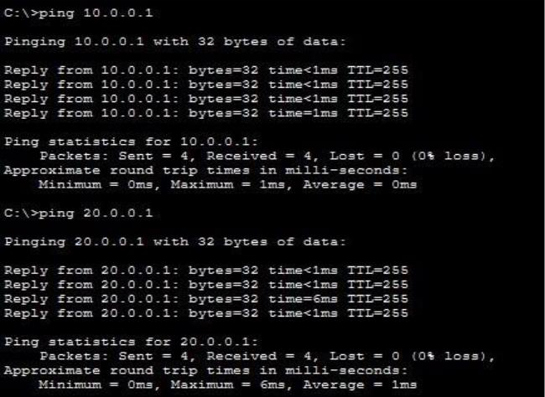
PC1:
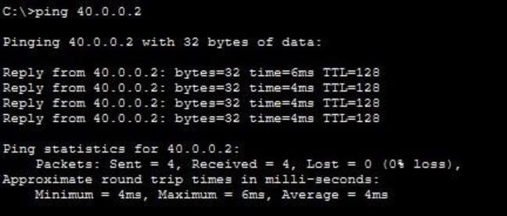
Conclusion:The above Topology has been executed successfully.

Q. Demonstrate Routing OSPF in packet tracer.

Aim: To write a code to demonstrate routing OSPF in packet tracer. Steps:
- In packet tracer take 2 PCs and 2 Routers.
- Connect Router0 with PC0 via fastethernet0/0 using cross-copper cord and Router1 with PC1 via fasethernet0/0 using cross-copper cord.
- Connect both router via fastethernet0/1 using cross-copper cord.
- Set the IP address and default gateway of both the PCs in ip configuration of both the PCs respectively.
Topology:
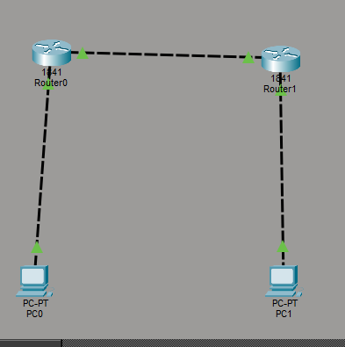

Code:
Router0:
Router> enable
Router# configure terminal

Router(config)# interface fastethernet0/0
Router(config-if)# ip address 192.168.1.1 255.255.255.0 Router(config-if)# no shutdown
Router(config-if)# exit
Router(config)# interface fastethernet0/1 Router(config-if)# ip address 10.0.0.1 255.255.255.0 Router(config-if)# no shutdown
Router(config-if)# exit Router(config)#router ospf 1
Router(config-router)#network 192.168.1.0 0.0.0.255 area 0 Router(config-router)#exit
Router1:
Router> enable
Router# configure terminal Router(config)# interface fastethernet0/0
Router(config-if)# ip address 10.0.0.2 255.255.255.0 Router(config-if)# no shutdown
Router(config-if)# exit
Router(config)# interface fastethernet0/1
Router(config-if)# ip address 192.168.2.1 255.255.255.0 Router(config-if)# no shutdown
Router(config-if)# exit Router(config)#router ospf 2
Router(config-router)#network 10.0.0.0 0.0.0.255 area 0
Router(config-router)#network 192.168.2.0 0.0.0.255 area 0 Router(config-router)#exit

Verification :In PC in command Prompt. PC0:
C:\ipconfig
C:\ping 192.168.2.10
Output:
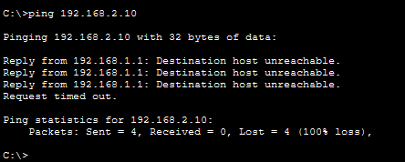

Verification: On any one Router Router#show ip ospf neighbor Router#show ip protocol Router#show ip protocol Output:
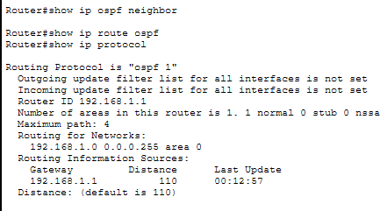

Conclusion : The above Topology has been executed successfully.

Q. Demonstrate the RIP Routing in Packet Tracer.
Aim : To write a code to demonstrate RIP routing in packet tracer. Steps:
- In packet tracer take 2 PCs and 2 Routers.
- Connect Router0 with PC0 via fastethernet0/0 using cross-copper cord and Router1 with PC1 via fasethernet0/0 using cross-copper cord.
- Connect both router via fastethernet0/1 using cross-copper cord.

- Set the IP address and default gateway of both the PCs in ip configuration of both the PCs respectively.

Topology:
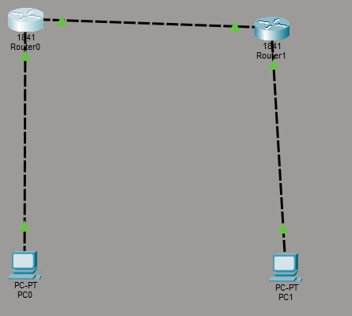

Router0:
Router> enable
Router# configure terminal Router(config)# interface fastethernet0/0
Router(config-if)# ip address 192.168.1.1 255.255.255.0 Router(config-if)# no shutdown
Router(config-if)# exit

Router(config)# interface gigabitEthernet0/1 Router(config-if)# ip address 10.0.0.1 255.255.255.0 Router(config-if)# no shutdown
Router(config-if)# exit Router(config)# router rip Router(config-router)# version 2
Router(config-router)# network 192.168.1.0
Router(config-router)# network 10.0.0.0 Router(config-router)# no auto-summary Router(config-router)# exit

Router(config)# end Router1:
Router> enable
Router# configure terminal
Router(config)# interface gigabitEthernet0/0 Router(config-if)# ip address 10.0.0.2 255.255.255.0 Router(config-if)# no shutdown
Router(config-if)# exit

Router(config)# interface gigabitEthernet0/1 Router(config-if)# ip address 192.168.2.1 255.255.255.0 Router(config-if)# no shutdown
Router(config-if)# exit Router(config)# router rip Router(config-router)# version 2

Router(config-router)# network 10.0.0.0
Router(config-router)# network 192.168.2.0 Router(config-router)# no auto-summary Router(config-router)# exit

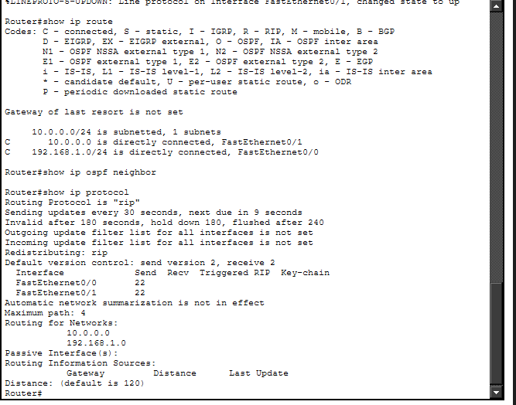
Router(config)# end Router#show ip route Router#show ip protocol Output:

Verification:In PC0 command prompt. C:>ipconfig
C:\>ping 192.168.2.2
Output:

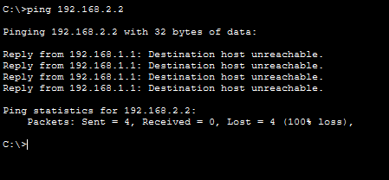

Conclusion:The abovee topology has been executed successfully.
Q. Demonstrate DHCP router in packet Tracer.
Aim:- To demonstrate DHCP server in packet Tracer. Setup:
(1). Router ,switch C 2 Pcs.
(2).Connect the Pcs to switch and connect switch t the router.
(3).Give router a ip address then in Pc0 C Pc1 click the radio button of DHCP in the ip configureration panel the values will be assingned directly.

Topology:
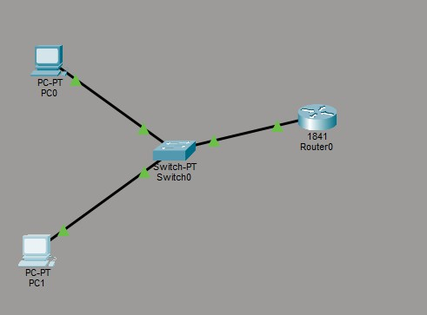

Code:
Router> enable
Router# configure terminal Router(config)#
Router(config)# interface fastEthernet0/0
Router(config-if)# ip address 192.168.10.1 255.255.255.0 Router(config-if)# no shutdown
Router(config-if)# exit
Router(config)# ip dhcp pool MYPOOL
Router(dhcp-config)# network 192.168.10.0 255.255.255.0
Router(dhcp-config)# default-router 192.168.10.1
Router(dhcp-config)# dns-server 8.8.8.8 Router(dhcp-config)# exit

Verification: In Both PCs Command Prompt.

PC0:
C:\ipconfig
C:\>ping 192.168.10.1
Output:-

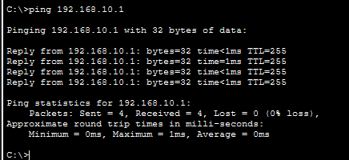

Conclusion:The above Topology has been executed successfully.

Q. Demonstrate DNS server in packet Tracer.
Aim:- To demonstrate DNS server in packet Tracer. Setup:
- One Pcs,One Switch C One server.
- Connect Pcs to switch and switch to server. (3).Then in server on the DNS services.
- Then origin ip address and DNS server .
- For Pc also origin ip address and DNS server ip of the server.

Topology:

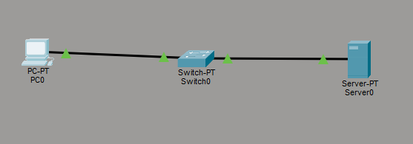

Config:
(1).Go to HTTP in server.
- There in file name index make some changes.
- Save it and then in DNS service add the name for the website and the DNS server and add that detail.
- Now go to Pc in there desktop click web browser and put the name of the file in URL and click go.
- If the topology work successfully then the website will be displayed.

Verification: In PCs Command Prompt. PC0:
C:\ipconfig
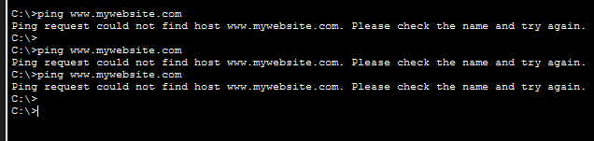
C:\ping www.mywebsite.com Output:

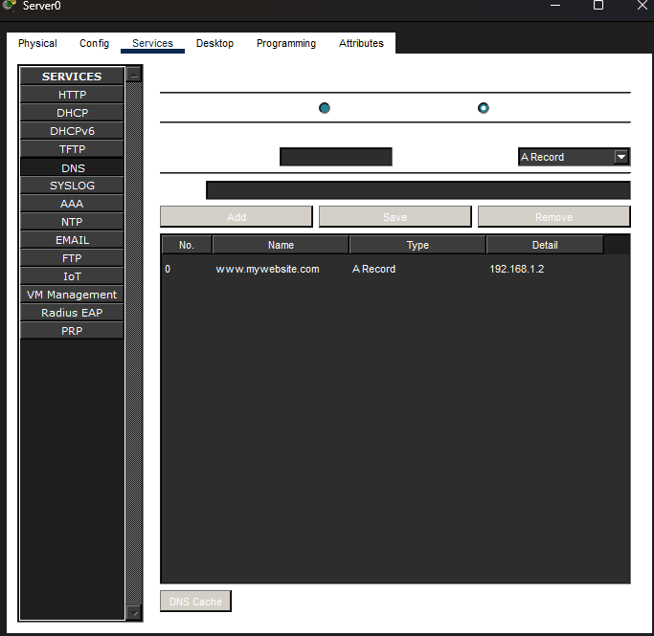
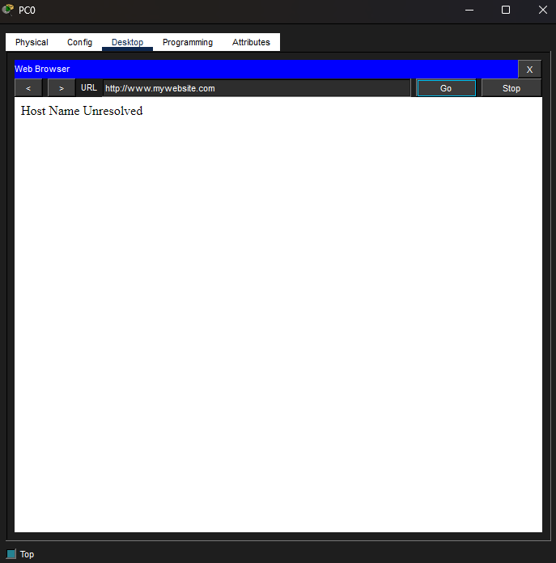

Conclusion:The above Topology has been executed successfully.

Q. Demonstrate FTP server in packet Tracer. Aim:-To demonstrate FTP server in packet tracer. Setup:
(1). 2 Pc , 1 switch, 1 server.
(2).Connect Pcs to switch and switch to server. Topology:

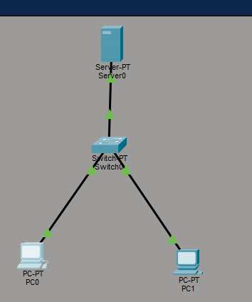

Config:
PC0
assign IP address | 192.168.1.10
Subnet Mask | 255.255.255.0
PC1
assign IP address | 192.168.1.11
Subnet Mask | 255.255.255.0
Server:
(1). Enable FTP option.
(2).Create username and password(123).
- Click all the 5 tick bores write , read ,Delete ,Rename list.
- Add it.

PC0:

C:\ipconfig
C:\>ping 192.168.1.2
C:\>ftp 192.168.1.2
ftp>dir Output:
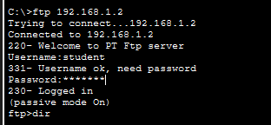

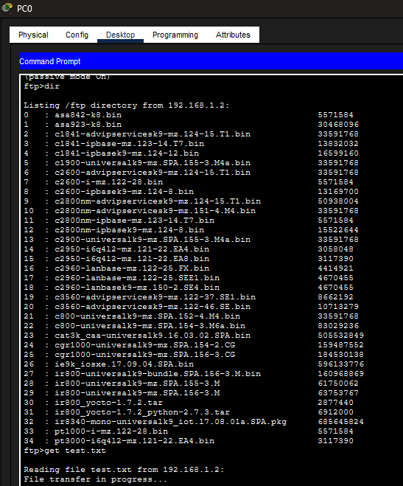

Conclusion:The above Topology has been executed successfully.

Q. Demonstrate HTTP server in Packet tracer.

Aim:- To demonstrate HTTP server in packet Tracer. Setup:
- 1 Pc ,1 switch ,2 Server.
- Connect Pc with switch and switch with the servers.
(3).Connect Router0 with PC0 via fastethernet0/0 using copper stright wire and Router1 with PC1 via fasethernet0/0 using cross-copper cord.
(4).Connect both router via fastethernet0/1 using cross-copper cord.
(5).Set the IP address and default gateway of both the PCs in ip configuration of both the PCs respectively.

Topology:
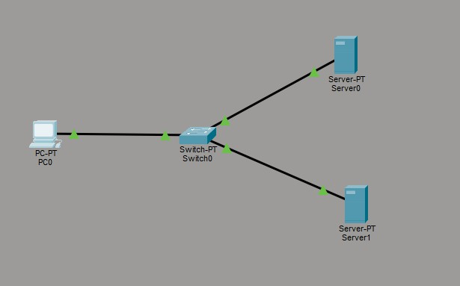

Config:
Server 0 (DNS Server)
Assign ip address 192.168.1.1

DNS Server 192.168.1.1
Server 1 (web server)
Assign ip address 192.168.1.2
DNS Server 192.168.1.1
DNS Server will be the same PC0
Assign ip address 192.168.1.3 DNS Server 192.168.1.1
- In DNS server 0 select and on DNS .
- Then go to web server http and edit the index.
- Name the website in DNS column and add the web server address and make on entity i the below list by clicking add.
- In PC0 open the desktop and then web browser write the name of the website if the edited html files contet displays ,then the topology has been succcessfully established.

PC0:
C:\ipconfig
C:\>ping 192.168.1.3
Output:
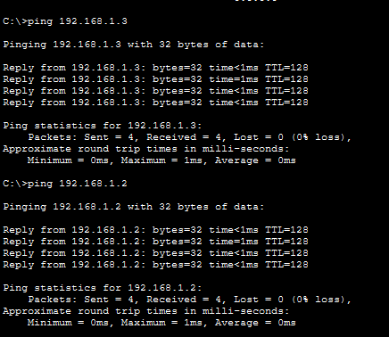

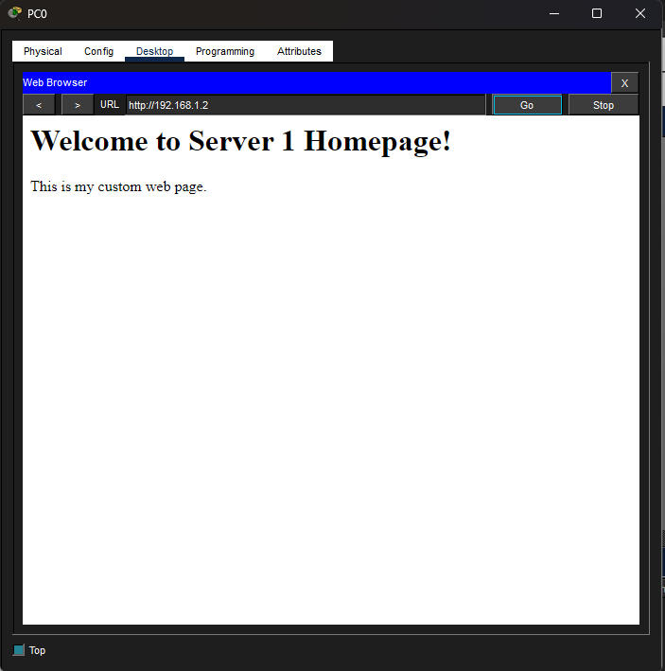

Conclusion:The above Topology has been executed successfully.

Q. Demonstrate telnet in packet Tracer.

Aim:-To demonstrate Telnet in packet Tracer. Setup:
- 1 PC , 1 Router , 1 switch.
- PC --->Switch--> Router connect using copper straight wire through cables.
- Do Router ,Switch interface Up. Topology:
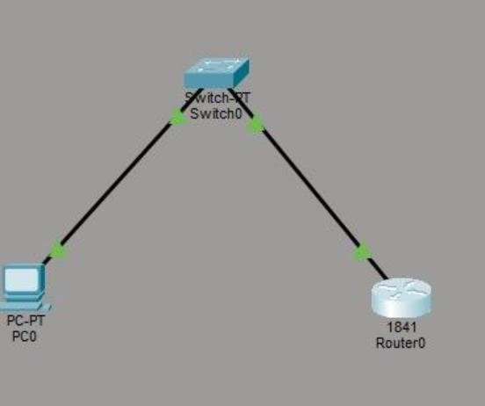

Config:
Switch :
Switch>enable Switch#configure terminal
Switch(config-if)# ip address) 192.168.1.2 255.255.255.0 Switch(config-if)# no shutdown
Switch(config-if)#exit Switch(config-if)# line vtg 04 Switch(config-if)# password cisco

Switch(config-line)#login Switch(config-line)#end Switch# write memory Router:
Router>enable Router#configure terminal
Router(config-if)# ip address 192.168.1.1 Router(config-if)#no shutdown Router(config-if)#exit
Router(config)# line vty 04 Router(config-line)# password cisco Router(config-line)#login Router(config-line)#end
Router# write memory

Verify: PC0:

C:\ipconfig
C:\>ping 192.168.1.1
Telnet 192.168.1.1
Telnet 192.168.1.2
Output:

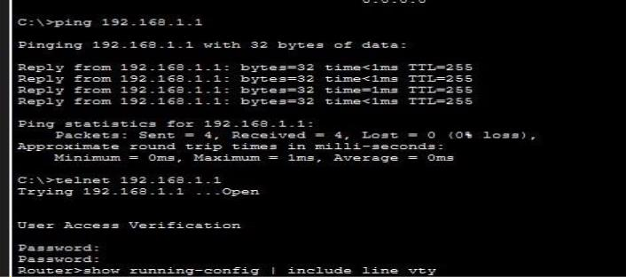

Conclusion:The above Topology has been executed successfully.

Study of cryptography substitution Techniques.

Q. Demonstrate substitution technique in C. Aim: To demonstrate substitution Technique in C. Program:-
#include <stdio.h> #include <conio.h> void main()
{
char str [26]; int i;
clrscr();
printf("Enter plain text: "); scanf("%s",C str);
for (i=0; str[i]:= '\0'; i++)
{
str[i] = str[i]+4; printf("Encrypted text: +4 In");
printf( Encrypted : %5 .s\n", str); for (i=0; str[i]:= 10;i++)
{
str[i] = str[i]-4;
}
printf(“Decrypted text:-4 \n”); printf(Decrypted:%>\n,str); getch();
}
Result:

Enter plain text:HELLO Encrypted text:+4 Encrypted:KHOOR Decrypted:-4 Decrypted: HELLO

Conclusion:The above program has been executed successfully.

Study of Symmetric Key.
Q.Demonstrate AES in Python.
Aim:-To write a python program to demonstrate AES in python. Program:-
! Pip install pycryptodome from crypto.cipher import AES
from Crypto.Util.Padding import pad import binascii
sykey=bytes.fromhex('2b7e151628aeb2a6abf7158809cf4f3c') originaltext=b"0123456789ABCDEF" ciphertext=AES.new(sykey,AES.MODE_ECB) cencrypt=ciphertext.encrypt(originaltext) print(cencrypt.hex)
ciphertext1=cencrypt.hex() ctext=AES.new(sykey,AES.MODE_ECB) btext=ctext.decrypt()
Result:

Conclusion: The above program has been executed successfully.

Study of Asymmetric key.
Q. Demonstrate RSA in python.
Aim: To write s program in python to demonstrate RSA. Program:
p=5 q=11
n=p*q
pn=(p-1)*(q-1) e=3
d=27
m=9 a=pow(m,e,n)
print("Cipher",a) decryption=pow(a,d,n) print("decrypted",decryption)

Result:
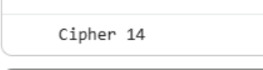


Conclusion:The above program has been executed successfully.

Study of MDS Algorithm

Q. Demontrate MDS algorithm in python.
Aim : To write a program to demonstrate MDS Algorithm in python. Program:
import hashlib str1="syit class"
md5hashvalue=hashlib.md5() print(md5hashvalue) md5hashvalue.update(str1.encode('utf-8')) md5hashvalue messagedigest=md5hashvalue.hexdigest() messagedigest
print(messagedigest)

Result:
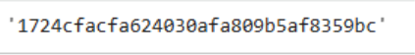

Conclusion: The above program has been executed successfully.

Study of Mash Function RSHash
Q.Demonstrate RSHash Function in python.

Aim: To write a python program to demonstrate RSHash function. Program:
def rshashvalue(str2): a=63689
b=378551
hashvalue=0
for ch in str2: hashvalue=(hashvalue*a+ord(ch)) a=a*b
return hashvalue & 0xFFFFFFFF h1=rshashvalue('syit class') Print(h1)

Result:

Conclusion: The above program has been executed successfully.

Practical G
Q. To create , Export and validate a Digital Certificate.

Aim: To write a code to create , Export and validate a Digital Certificate. Steps :
- Download and open ssl.
- Add its bin path in envirnment variable.
- Open command prompt.

Program:
C:\user\desktop>open reg-509 –day 365 –newkey rsa:204:keyout private-key pem-out certificate.pem
Enter PEM Pass : 123456 Country Name (2 letter code): IN
State or ProvinceName (Full Name):Mharashtra Locality Name[]: Mumbai
Organization Name : SIWS Organization Unit Name : iT Comman name :TMD
Email Address cs: vishwakarmakhushi442@gmail.com
C:\user\desktop>openssl pkcs12 –export –in certificate pem –inkey private-key.pem -out TMD.pfx
Enter Export Password:123456
Verifying – Enter Export Password:123456
>openssl pkcs12 –inTMD.pfx -clcerts –nokey – out public-key.pem Enter Import password:123456
Import the certificate. Result:

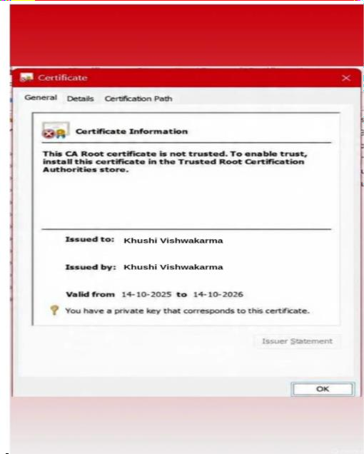
Conclusion: The above certificate is done successfully.

